1. **Ansible Lab 1 - Installation and Inventory file basics**

Creating and running the virtual machines using the Vagrantfile

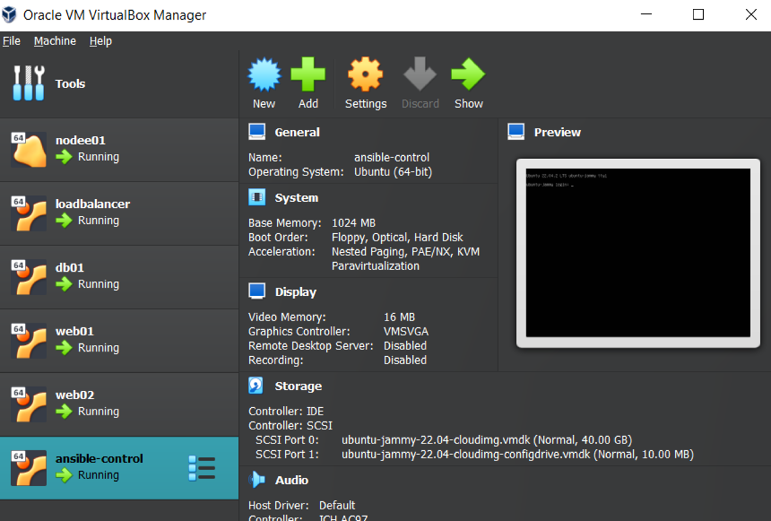

Connect to ansible-control server

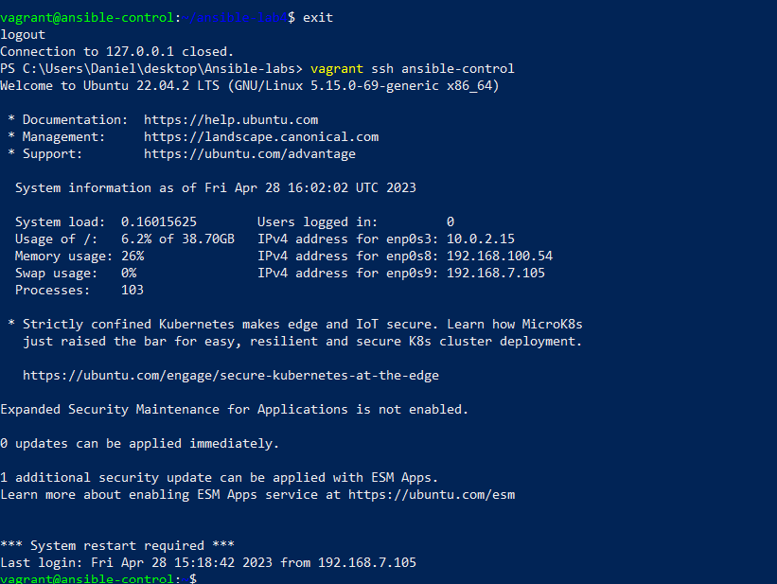

Testing for localhost and date :

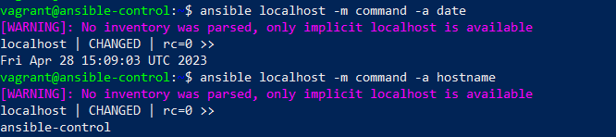

Run an ad-hoc command to the webstack group that we created and set

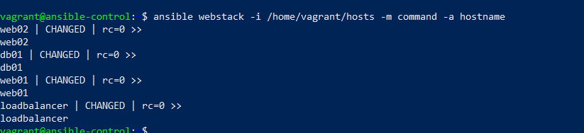

1. **Ansible Lab 2 - Ad HOC tasks and Modules**

Get the uptime of all the hosts

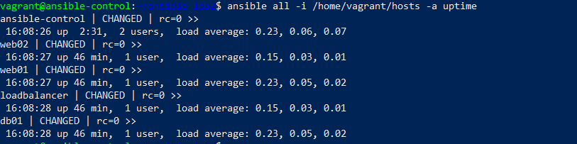

Get the free memory of all the hosts

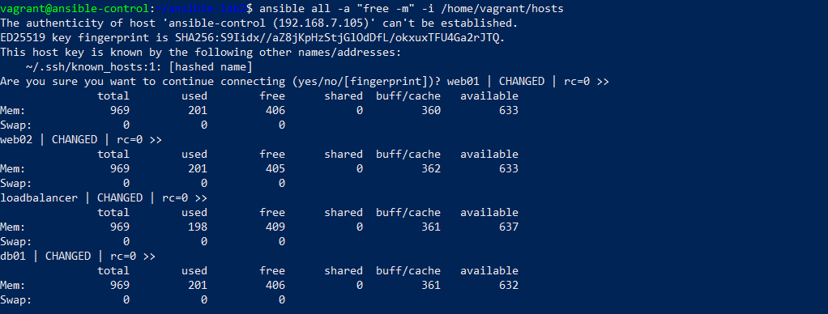

Use ansible to reboot webstack  
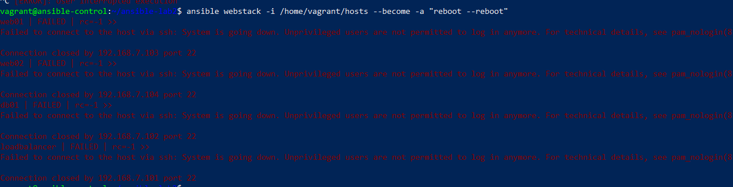

1. **Ansible Lab 3 - Playbooks, Templates and Handlers**

Create the playbook  
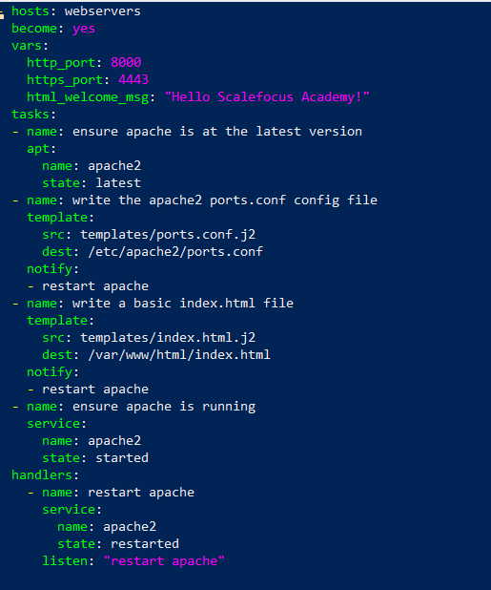

Run the playbook  
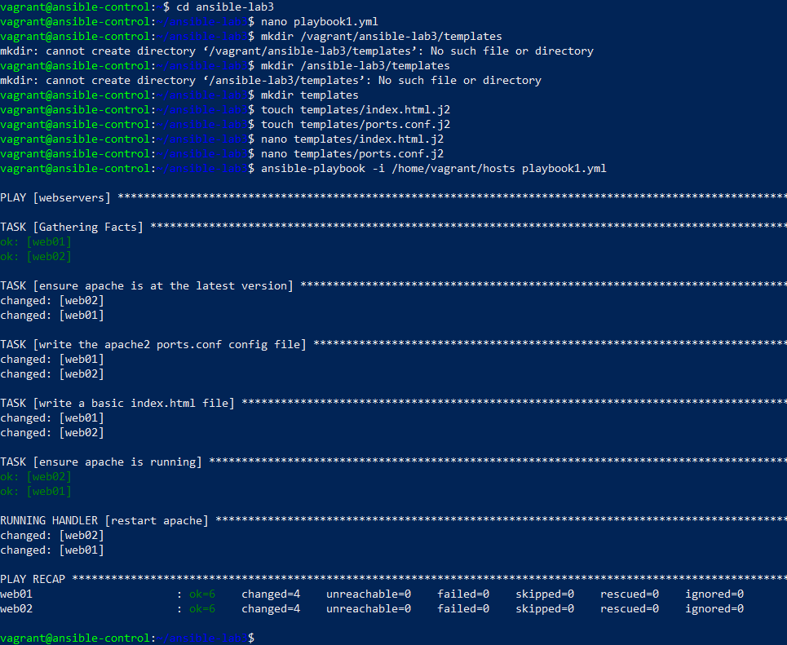

Test connectivity to servers  
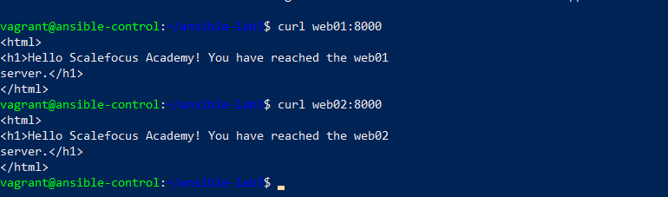

1. **Ansible Lab 4 - Re-usable playbooks, import_tasks, Roles and Ansible Galaxy**

Move around our code, and use the import_tasks.  
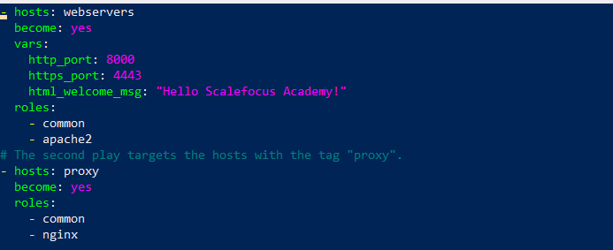

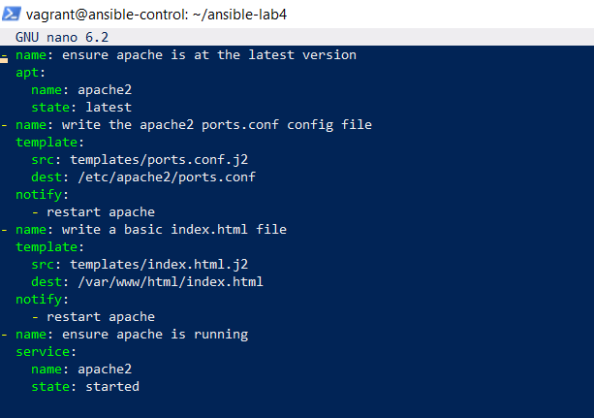

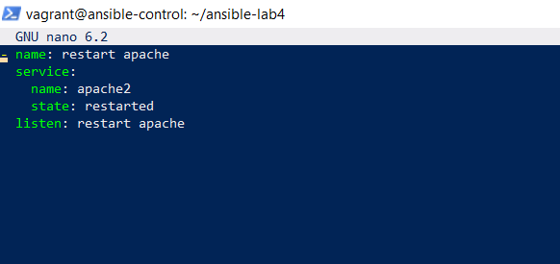

Checking the tree after all the roles :   
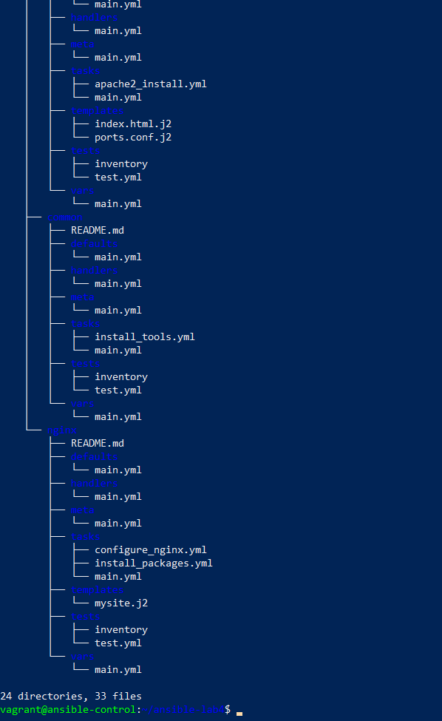

Run the playbook and test.

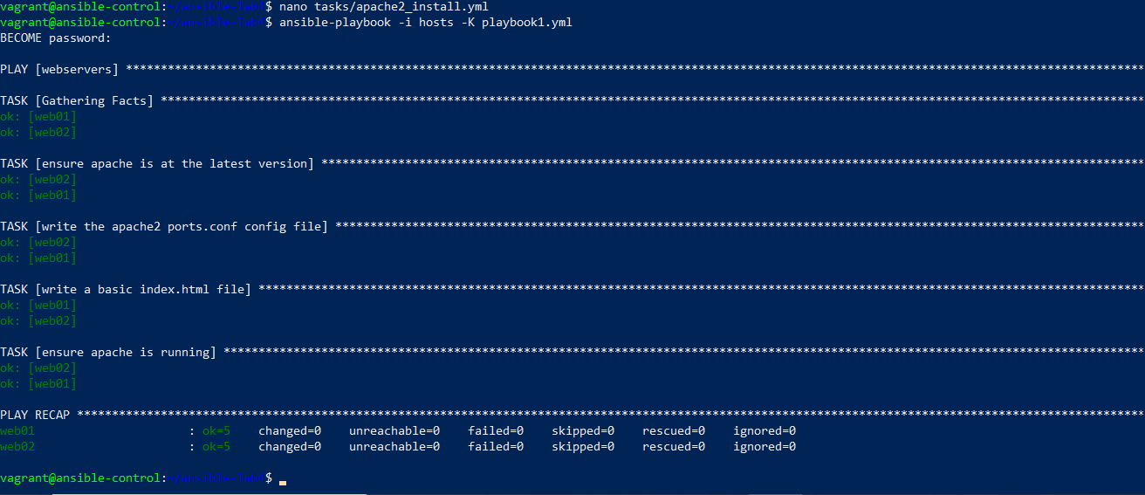

**Ansible Lab 5 - Variables, Ansible Vault**

Running the playbook with the prompt for a vault password

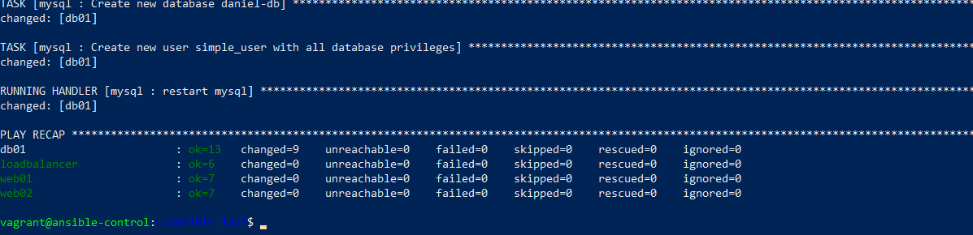

Test a mysql connection to database and show the database

